Greetings from Millington,

A quick overview/agenda for the September OP Drumbeat. Intend to cover Career Counselor Updates, Remarks from the Chief, Eisenhower School / Joint Acculturation Brief, Q&A, and Closing Remarks.

CAPT Risley: Opening Remarks:

Good afternoon and welcome to the September OP Drumbeat TEAMS series. This month will be our first panel discussion covering Eisenhower School / Joint matters in the Supply Corps. Thank you to the Eisenhower School students and faculty for being the first to volunteer to support a panel discussion. Turns over to the Career Counselor for updates/announcements.

LCDR Mays: Career Counselor Updates:

1. Fall Internship Packages are due 30th Sep 2024. Please make sure any JOs interested send their package to LTJG Max Collins before the deadline ([max.d.collins3.mil@us.navy.mil](mailto:max.d.collins3.mil@us.navy.mil)).
2. Reminder about the Career Counselor Corner where you can find Drumbeat recordings and summary of Drumbeats in case you missed the live event. Email the career counselor if you’re having trouble finding the link ([supply_corps_cc@navy.mil](mailto:supply_corps_cc@navy.mil)).
3. Board and Roadshow season is quickly approaching. Please get in the habit of reviewing your record and saving a copy so you can track any changes. If you’re not in zone for a board we recommend reviewing every 6 months, and if in zone, we recommend every 3 months. As always if you’d like a courtesy look please reach out to the Career Counselor or your detailer.

Turns it over to the Chief for remarks/comments.

Chief: Remarks on Drumbeat and Eisenhower School:

Good afternoon Team. I’m very excited for this topic. As you know I am both a graduate of the program and former faculty. This educational opportunity has been the most meaningful and impactful to me professionally. The Eisenhower School was better than my college and 810 experience. The timing and how you do Eisenhower School make it such a monumentally important curriculum that I hope when we’re done with this presentation, you are all clamoring to get into next year’s class. Secondly, I value this program so much that my current EA (CDR Jen Traul) is going to Eisenhower School next year. With that let’s turn it over to the Eisenhower School.

Eisenhower School: CDR Walls Remuis, CDR Norman Christopher, and CDR Hunt David

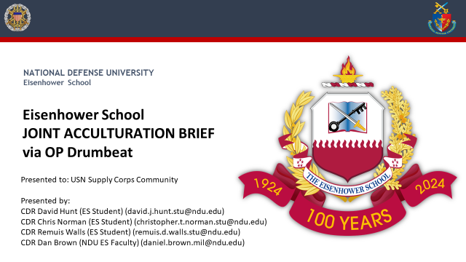

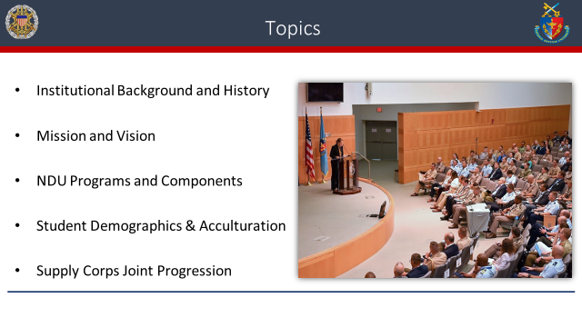

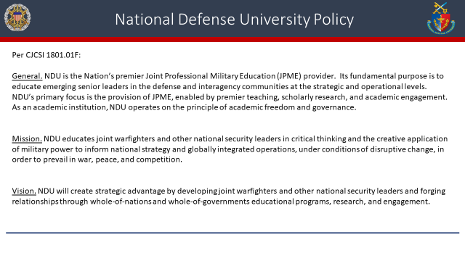

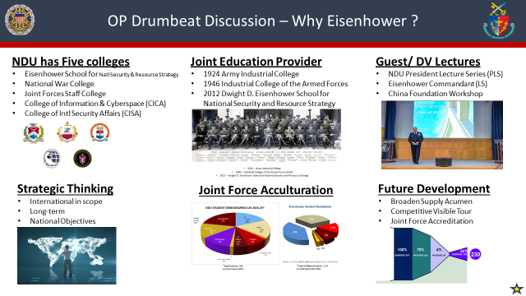

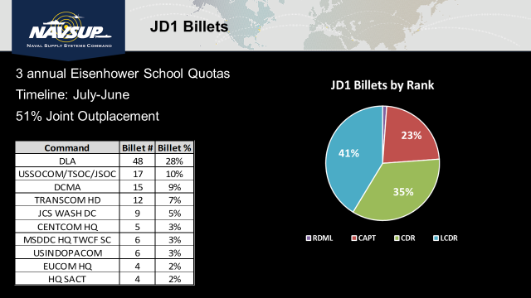

**Back-up Slides**

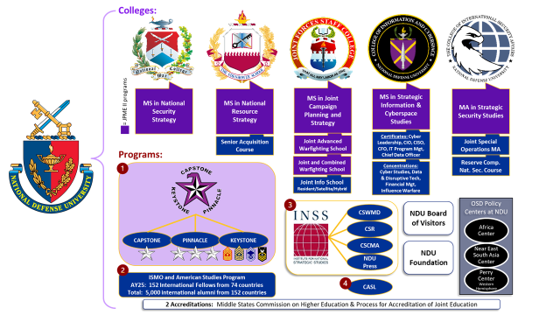

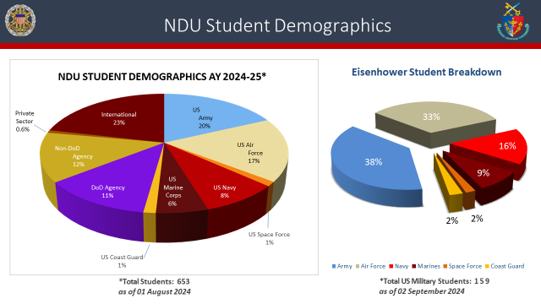

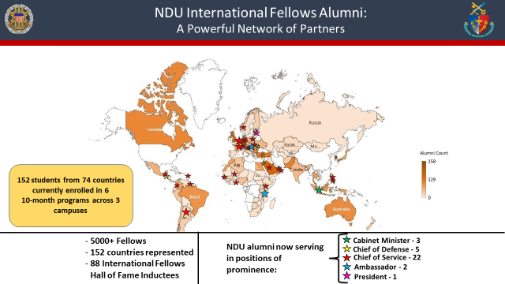

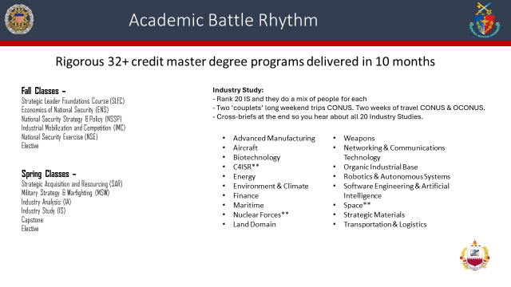

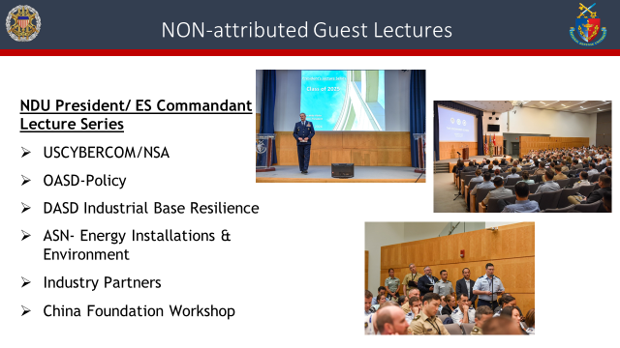

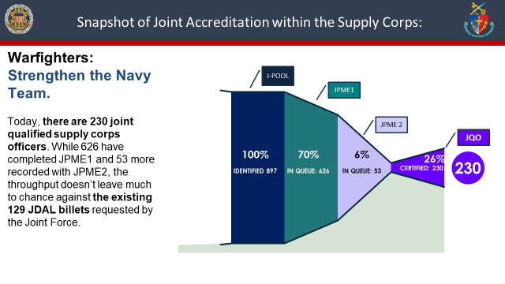

_____________________________________________________________________________________

Q & A Session:

Q1. CDR Ileto: It was mentioned that at the Eisenhower school that they facilitate engagement with the industrial base. Now I know one of the SECNAV’s priorities is shipbuilding, and just last week the Navy established a direct reporting program manager for the Maritime industrial base. I was there at the establishment and what they're trying to do is build on the submarine industrial base or the SIEB in the surface combatant industrial base of engaging with industry. Now, I know that Eisenhower School fulfills the requirement of JPME 2 and that you just talked about the 51% joint outplacement, but has OP considered sending previous graduates who have either fulfilled their joint payback to focus on engaging with the industrial base?

A1. CAPT Risley: Great question. I don't have statistics or numbers off the top of my head, but point taken that we need to strategically place our graduates in those types of assignments. We will take a look at where our past graduates have gone immediately after graduation. I would venture to say the billet you may be referring to at a shipyard, may not be joint coded, so that might have to factor in. The slide that you saw previously is where the majority of our joint billets are and would be the initial priority, and if the billet fell in that category, then absolutely that's where we should be sending our students post-Eisenhower.

Q2. CVN-77: What are requirements for rank to go to Eisenhower? Can an O4 go or does it have to be O5 select or O5?

A2. CAPT Risley: It does need to be an O5 select or higher. We have not been successful with getting waivers for O4's unfortunately, and since we're on the conversation of waivers, I do want to mention that we have had previous challenges with those who had JMPE 2 already or those that are fully JQO qualified. However, we can submit a waiver for those students.

Q3. LCDR Garrett: I know that you mentioned additional opportunities for research. Are there capstone opportunities that you are able to employ through this school?

A3. Eisenhower School: No, that's one of the things here. So I didn't get a chance to really read a lot of this, but in the details we have industry studies and in our classes we're actually addressing issues that we think we need to highlight. There is an elective you can take where you have more freedom to investigate something I believe is within the defense industrial base where you do it at your own pace. With assistance from staff, we have more freedom, but other than that, the topics for the research we do is pretty much coincides with what the class is asking of us. I'll also add that there are some joint questions that come from the Joint Staff that you can volunteer to answer and do research throughout the year on our own independent time as well as the “A" scholar presidential scholar program that we can do as well.

_____________________________________________________________________________________

CAPT (SEL) Paben: Community Announcement:

Supply Corps Community All Calls will be 22NOV24 from 1830 – 2300 at the National Press Club in Washington D.C.

POC: CDR Matthew Schaefer: [matthew.j.schaefer.mil@us.navy.mil](mailto:matthew.j.schaefer.mil@us.navy.mil)

***Official invites will be out shortly***

_____________________________________________________________________________________

Chief: Closing Remarks:

Thank you to the OP team for doing this. I like the new format and it is awesome. Thank you to the 3 current Eisenhower students for taking the time to do this presentation. Really nice job. I cannot be more excited about the Eisenhower School, and it's not just because I'm a former student, but I taught there for a year as well. It is like a ticket to Hogwarts now, literally Hogwarts. If you go on the NDU campus it is really National War College, and when you go visit them, you will see the building looks like Hogwarts. It's the most amazing opportunity you will get in the uniform and like they said, if you look at the other services, they only screen their future GOs (General Officers) for this class. This is the ultimate in iron sharpening iron. They send the absolute best. So if you always felt like at 18, you wanted to go to Princeton and you just missed the cut, now you have a shot at however old you're going to be to go there. I cannot sell it enough. Eisenhower is absolutely designed for us logisticians. It's like a tailor made class. Folks, you should be knocking down Millington's door to try to get in there, and if we need to help you, if I need to sign a waiver to help someone get through and you're a deserving person we want to push through, I will commit myself to this now. Finally, like I said, I'm a graduate, but most recently Admiral Heinz was a graduate, and so was Admiral Ott. So, you know clearly this is a fast path educational opportunity and I can't thank the team enough for sharing their experience.